Report title
Subtitle
Team and Class

Report title and subtitle is defined by writing in the fields ”Title” and ”Subject” in Document Properties. (Choose File > Properties > Summary). Right click and choose Update Field, to update the actual field (on all subsequent pages).

Supervisor(s):

Student name | Student number | Signature
Victor S Añasco Jativa | 90214
Table of Contents

1. Introduction 4
1.1 System description 4
1.2 Risk management 4
1.2.1 PC part 4
1.3 Milestone plan 5
1.3.1 PC part 5
2. User manual 6
2.1.1 PC part 7
3. Requirements specification 7
3.1 PC part System requirements specification (SRS) 7
3.1.1 Functional requirements 7
3.1.1.1 Use case model 8
3.1.1.2 Requirements tracing 12
3.1.2 Non functional requirements 12
4. Problem Solution 13
4.1 Domain model 13
4.1.1 Class responsibilities 14
4.1.2 Use case realization 15
4.2 Design model 19
4.2.1 Solution classes/Interfaces 20
4.2.2 Use case realization 20
5. Problem solution, Communication protocol 22
6. Testing 23
6.1 PC part 23
6.1.1 Acceptance Tests 23
To see the detailed reults go to the Appendix “9.4.1 Acceptance Tests” 23
6.1.2 Unit Tests 24
7. Conclusion 24
7.1 Product oriented conclusion 24
7.1.1 PC part 24
7.2 Process oriented conclusion 25
8. Literature 26
9. Appendices 26
9.1 Glossary 26
9.1.1 PC part 26
9.2 Time schedule 26
9.2.1 PC part 26
9.3 Action item list 27
9.3.1 PC part 27
9.4 Test results, PC part 27
9.4.1 Acceptance Tests 27
9.4.2 Unit Tests 29
9.5 Source code Java 30
9.6 Use case specifications 31

Note: The Table of Contents above is automatically updated. So, do not change anything on this page. The changes you make on the following pages are updated when you right click on Table of Contents and choose Update field. Remember to format Heading 1, Heading 2 etc. (Choose format and Style)

Introduction

System description
The system must be able to manage the data that comes from the BC-System, this data is divided into two fields, the pulse of the bike rider and the speed of the bike. This data must be showed in a graphical way. So in the program will appear the Pulse Graph (pulse of the bike rider versus the time ) and the Speed Graph ( speed of the Bike Rider versus time ).

There is the possibility to save the Bike Data of a Training Session, this data will be kept in a file which name will be chosen by the user. The user must be able to restore the Bike Data of a previous Training Session, choosing a text file.

Risk management

PC part

Risk | Probability | Impact | How to relieve the risk
Lack of knowledge among software developers | Medium | Medium | - Education, courses  - Get help from the teacher
Serial communication between the BC simulator and BMA. | Medium | High | - Use library classes supplied by the teacher  - Build a simple prototype
Within the Team the following issues are present:  - Team contract not present or not operational.  - The individual Team member doesn’t know hers/his role.  - Power struggles among Team members. | Medium | High | - Establish a clear Team contract from the beginning  - Regular communication  - Ask the teacher for help

Milestone plan

PC part

For each iteration (milestone) the table below shows, what tasks, deliverables and/or achievements the individual iteration consists of.

Iteration | Tasks | Deliverables
Iter. 1  Start: 06/03/09  End: 17/03/09 | Establish project objectives (Vision)  Identify critical project risks  Capture primary System Requirements  Define Use Cases  Prioritize Use Cases | Project Report issue 1.x including:  - Risk analysis  - Primary SRS  - Use Case Diagram and UC specifications  - Requirements Traceability Matrix.
Iter. 2  Start: 17/03/09  End: 27/03/09 | Realize the basic core use case(s) eg. receiving data generated by a bike data simulator. | Project Report issue 2.x including:  - Analysis Model  - Class responsibilities  - Design Model
Iter. 2  Start: 17/03/09  End: 27/03/09 | Define Analysis Model  Define Preliminary Design Model
Iter. 2  Start: 17/03/09  End: 27/03/09 | Consider application of the Observer Design Pattern.  Consider application of the MVC architecture.
Iter. 3  Start: 27/03/09  Ends: 07/04/09 | Realize use cases relating to eg. saving bike data objects received to file and restoring from file.  Update:  - Analysis Model  - Class responsibilities  - Design Model
Iter. 4  Start: 07/04/09  Ends: 24/04/09 | Realize use cases relating to eg. graphical display of current pulse and speed and restore graph display of Pulse and speed from earlier trainings sessions.  Run Test cases. | Project Report issue 3.x including updated:  Updated documentation for:  - Design Model  - Class responsibilities  - Use Case realizations  - Test cases
Iter. 5  Start: 24/04/09  Ends: 12/05/09 | Complete use case realizations.
Iter. 6  Start: 12/05/09  Ends: 26/05/09 | Complete use case realizations.  Perform acceptance testing | Four copies of project report issue 4.x with CD containing BMA NetBeans project-file should be delivered by 12.00pm 26/05/09.

It was hard to accomplish all the milestone program, that's why making this project were found many delays specially in the research of information and in the programming of the program .

User manual

PC part

Start running the application
To run the application we have to run the class called GUI_BP_1, then it will appear the main window like this.
Note: To receive the data properly, the System Simulator must be started.

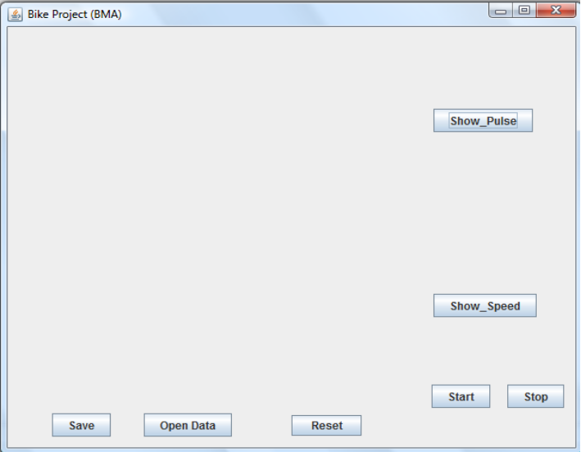

Show Pulse
If we press the button Show_Pulse, there will be the graphic of the pulse.
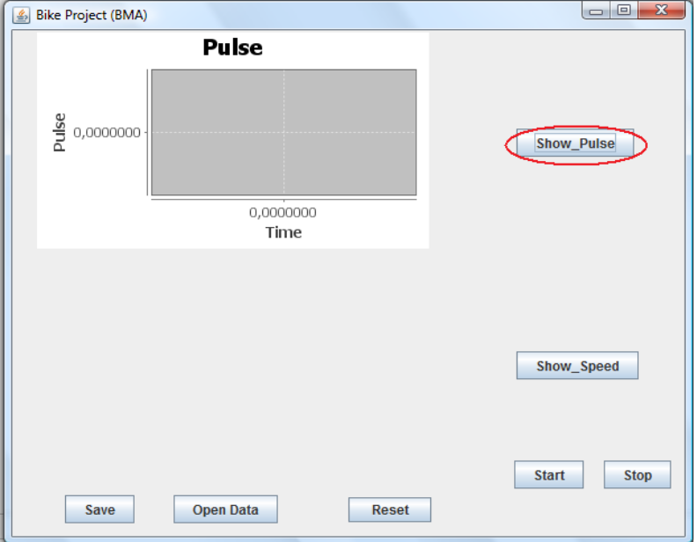

Show Speed
If we press the button Show_Speed, there will be the graphic of the speed.

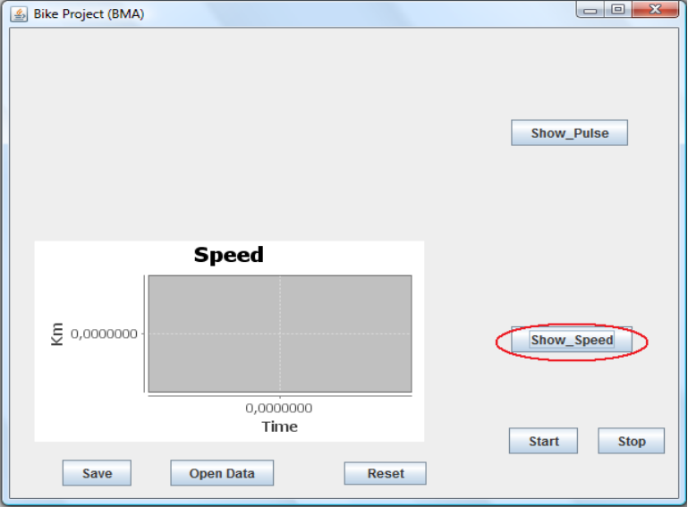

Start
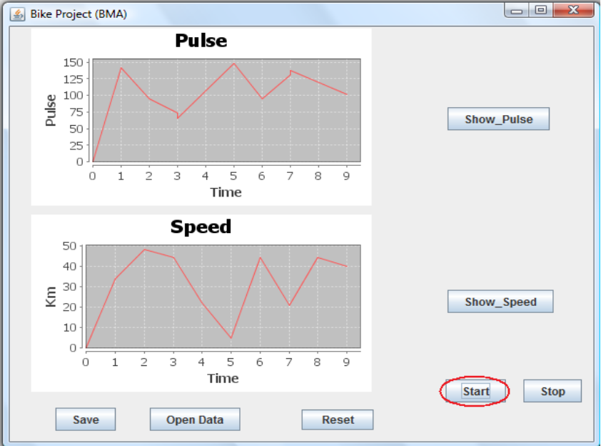
If we press the button Start, then we ordered to our application to open the port and it will start receiving the data, an showing this data in the Speed and Pulse Graphics.

Stop
If we press the button Stop, then we ordered to our application to close the port and it will stop receiving the data, and the Speed and Pulse Graphics will be frozen.

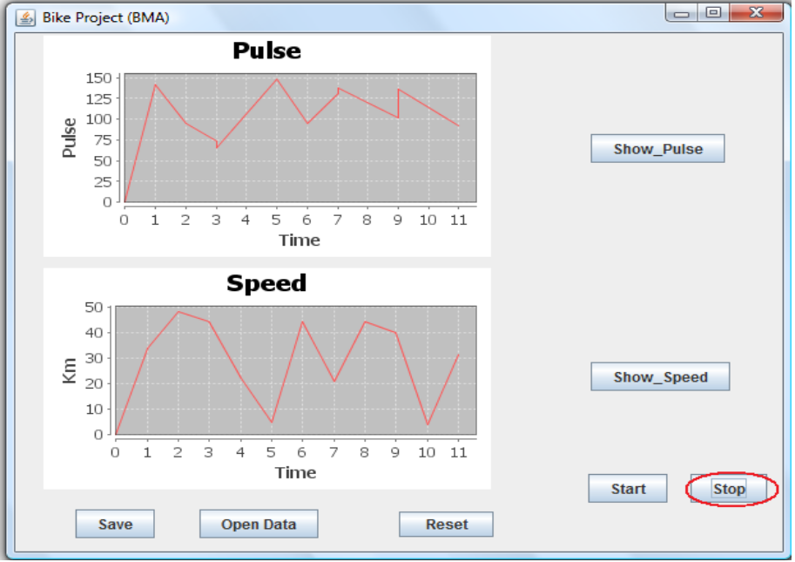

Save
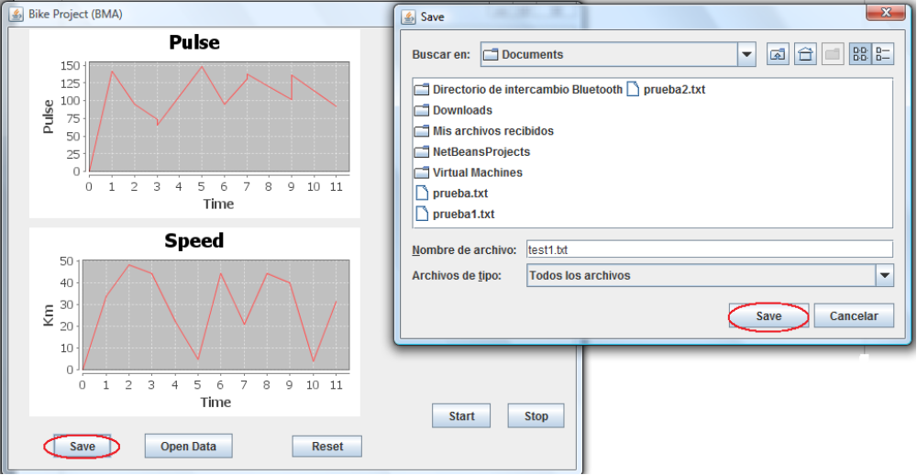
If we press the button Save, then it will appear a FileChooser where we will have to insert a name to save the training session, ant then press save to confirm and save the training session.

Open Data
If we press the button Open_Data, then it will appear a FileChooser where we will have to choose the file that contains the training session, ant then open to confirm and save the training session.
Note:After opening the training session this must be draw in the Speed/Pulse Graphic, but there is a error and the data from the training session opened is not drawn well.
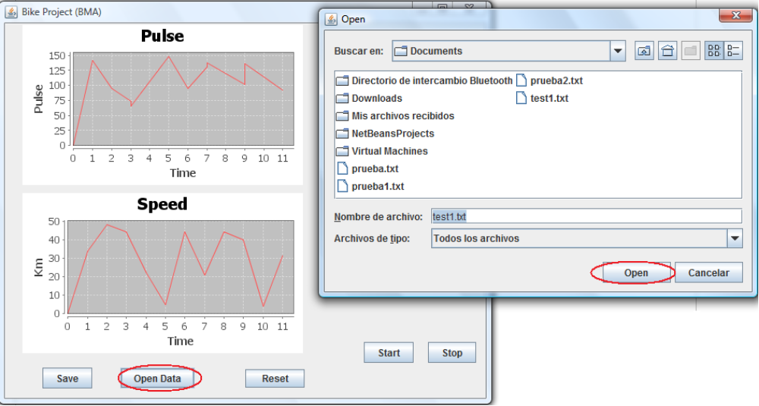

Reset
If we press the button Reset, then the Speed/Pulse Graphic will be reinitialized, and all data that is keep in our program will be cleared (or erased).
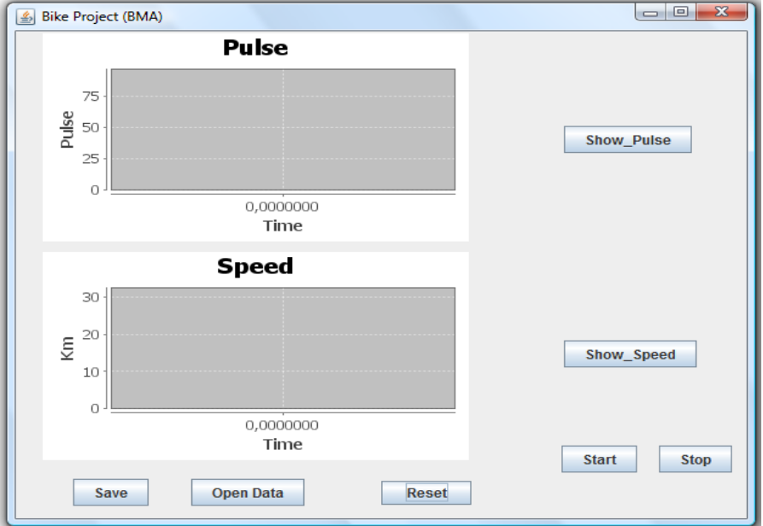

Requirements specification

PC part System requirements specification (SRS)

Functional requirements
The table below defines the primary set of requirements provided by the teacher.

Functional requirements
R2 | The BMA shall receive simulated Bike Data from a simulator.
R4 | While a Training Session is ongoing the Trainings Program shall be monitored as a graph in a window; this graph is named the Training Graph.
R6 | The user shall be able to monitor the Pulse Graph showing the pulse of the Bike rider versus time.
R7 | The user shall be able to monitor the Speed Graph showing the speed of the Bike rider versus time.
R8 | The user shall be able to choose to monitor both of the Pulse – and Speed graph simultaneously or none of them.
R9 | The user shall be able to save the complete number of Bike Data from a Training Session. The name of the file into which Bike Data is saved is chosen by the user.  This must be a txt a dat, whatever is better a sequencial file to keep the array list
R10 | The user shall be able to restore Bike Data saved from previously Training Sessions.
R11 | The user shall be able to monitor Pulse – and/or Speed Graph for previously Training Sessions.

Use case model
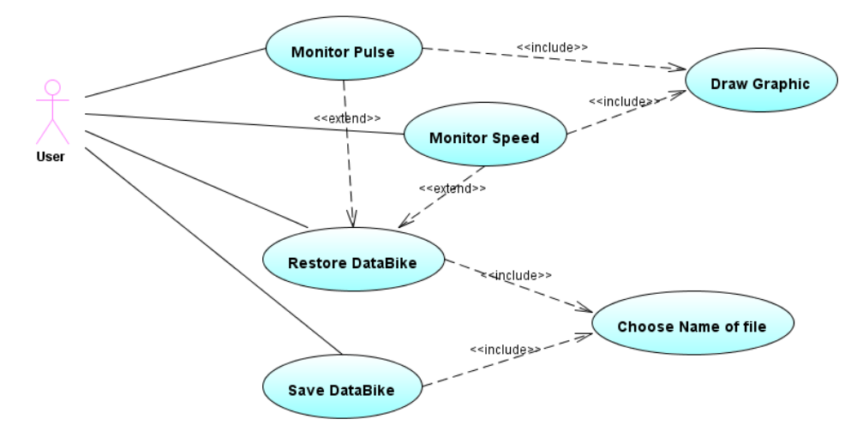

This user case shows the most important functionalities that our program gives.
- Show Monitor
- Show Pulse
- Save Training Session
- Open Training Session

The use case specification are in the appendix, in the point “ 9.5 Use case specifications” .

Requirements tracing

Requirements | UC1
R2
R4
R6
R7
R8
R9
R10
R11

Non functional requirements
Non functional requirements
NR1 | The BMA shall be implemented in Java by means of the Netbeans IDE.
NR2 | The version used are the following:  - Java: Later or equal to 1.5.0.6  - NetBeans: V 6.5
NR3 | The BMA shall be developed in accordance to UP.
NR4 | The BMA shall be developed and documented in accordance to the model and directions given in UML 1.4
NR5 | The present report template shall be used.
NR6 | The quality of the BMA shall be documented according to the Test Cases defined in this report template. At least 3 classes shall be Unit Tested.
NR7 | This report shall explicitly describe the tradeoffs considered in the construction.
NR8 | Simulated Bike Data are received in fixed time intervals (for example each 10th second) from the BC-system simulator.
NR9 | Bike Data shall consist of pulse and speed as a minimum.
NR11 | The Training Graph shall be divided into a number of loading ranges (gear), each of which should not be less than 60 seconds in duration.
NR12 | Bike Data shall not be monitored nor registered by the BMA unless a Training Session has been selected by the user.

Problem Solution

Domain model
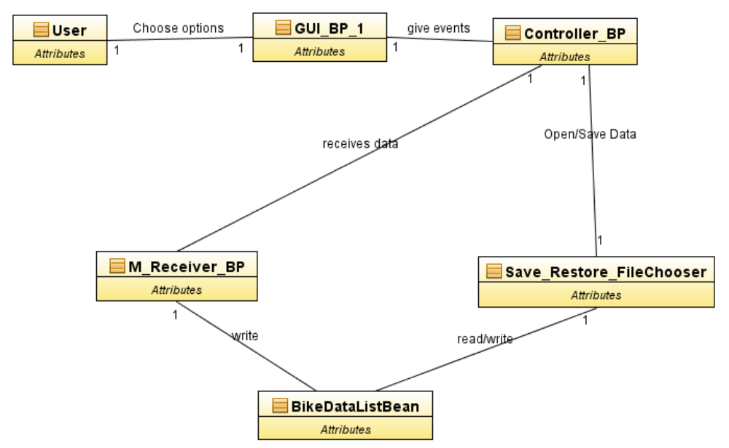

The Domain Model encapsulates the “Business Rules”, so it represents the system entities, its attributes, methods and relationships. Here we describe the information System
We used the MVC ( model, view, controller ). The GUI_BP is the graphic user interface this is the interface between the user and the program.
The GUI_BP give events (from the buttons) to the Controller_BP , this class manages to the classes that are part of the model (M_Receiver_BP, Save_Restore_FileChooser and BikeDataListBeans).

M_Receiver_BP, is responsible of receiving the data from the simulator, and write this data received in the BikeDataListBean.
Save_Restore_FileChooser manage the actions to save and open the data into a file.
BikeDataListBean here we keep the data received from the simulator. And also we used this class to save and to open the data into/from the file text.

Class responsibilities

Class name: GUI_BP
Responsibility:  Graphical User Interface Bike Project  Main Class . Show us all frames, the buttons and all functionalities that our aplication gives to the user. | Collaboration:  Controller_BP  M_Receiver_BP

Class name: M_Reciever_FileChooser
Responsibility:  This class recieves the data from the serial port. Keeps in an ArrayList of BikeData | Collaboration:  BikeDataListBean  GUI_BP

Class name: Save_Restore_FileChooser
Responsibility:  This class Saves/Restores data bike from a training session. It's helped by a File_Chooser to save/restore the data (a file) | Collaboration:  BikeDataListBean  Controller_BP

Class name: BikeDataListBean
Responsibility:  This class keeps an ArrayList of BikeData and gives all functionalities needed to manage this ArrayList. If there is any change in the ArrayList this class, notifies this change to the  listeners (the view), calling this method "propertySupport.firePropertyChange" | Collaboration:  M_Receiver_BP  Save_Restore_FileChooser

Use case realization

Restore DataBike

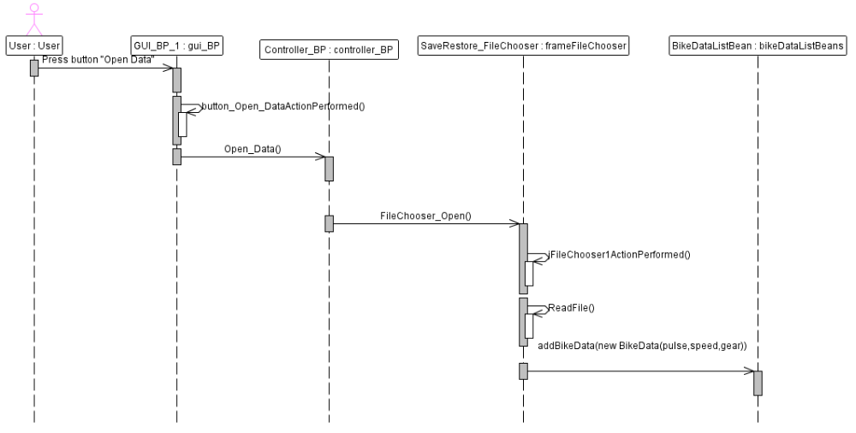

Here are showed the steps to choose a file to restore a previous training session.

User : is the person that chooses option and manages the BMA.

gui_BP : is the object that represents the graphical interface, (the view of the MVC), implements all the methods to show the graphics to the user (except the fileChooser).
- button_Open_DataActionPerformed(), this method keeps the event originated of pressing the button “Open_Data”, and also calls to OpenData () in the controller_BP.

Controller_BP : is the object that represents the controller of the MVC. This object Receive the events and has the rules to manage this events.
- OpenData (), is a method to manage an event from the gui_BP.

frameFileChooser : this object shows to the user a frame that contains a FileChooser,also this object has all the rules and methods to save/open a file, and to write/read the information used in the bikeDataListBean
- jFileChooser1ActionPerformed() ,this method receives the events in the button Open/Save
- FileChooser_Open (), is method a that makes that the frameFileChooser shows the user the interface to open a file .

- ReadFile (), this method has all the implementation to manage a file (to read it)

bikeDataListBean : this objet keeps an ArrayList of BikeData and gives all functionalities needed to manage this ArrayList.
- addBikeData: this method is used to add a BikeData (object that keeps the pulse, speed and gear).

Save DataBike
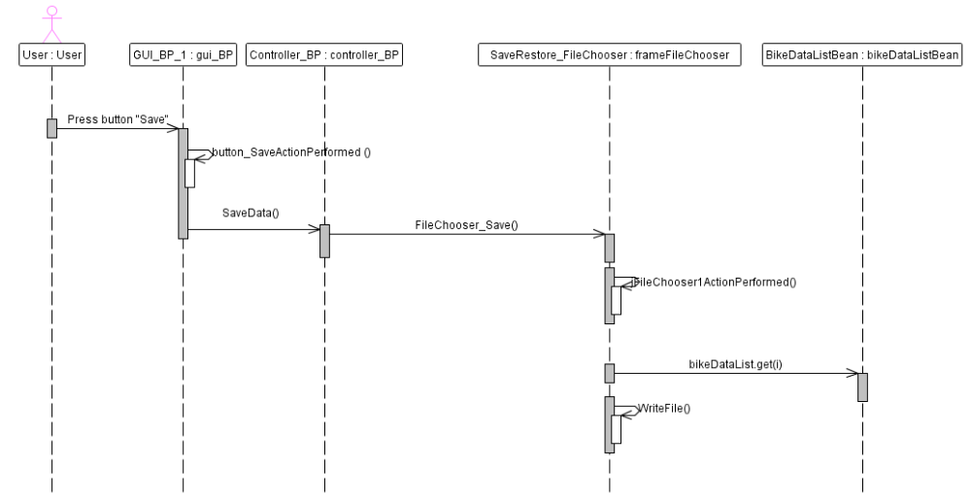

Here are showed the steps to choose a file to save training session.

User : is the person that chooses option and manages the BMA.

gui_BP : is the object that represents the graphical interface, (the view of the MVC), implements all the methods to show the graphics to the user (except the fileChooser).
- button_SaveActionPerformed(), this method keeps the event originated of pressing the button “Save”, and also calls to SaveData () in the controller_BP.

Controller_BP : is the object that represents the controller of the MVC. This object Receive the events and has the rules to manage this events.
- SaveData (), is a method to manage an event from the gui_BP.

frameFileChooser : this object shows to the user a frame that contains a FileChooser,also this object has all the rules and methods to save/open a file, and to write/read the information used in the bikeDataListBean
- jFileChooser1ActionPerformed() ,this method receives the events in the button Open/Save
- FileChooser_Save (), is method a that makes that the frameFileChooser shows the user the interface to save a file .

- WriteFile (), this method has all the implementation to manage a file (to write it)

bikeDataListBean : this objet keeps an ArrayList of BikeData and gives all functionalities needed to manage this ArrayList.
- BikeDataList.get(i): this method is used to get a BikeData (object that keeps the pulse, speed and gear), from the BikeDataList.

Design model
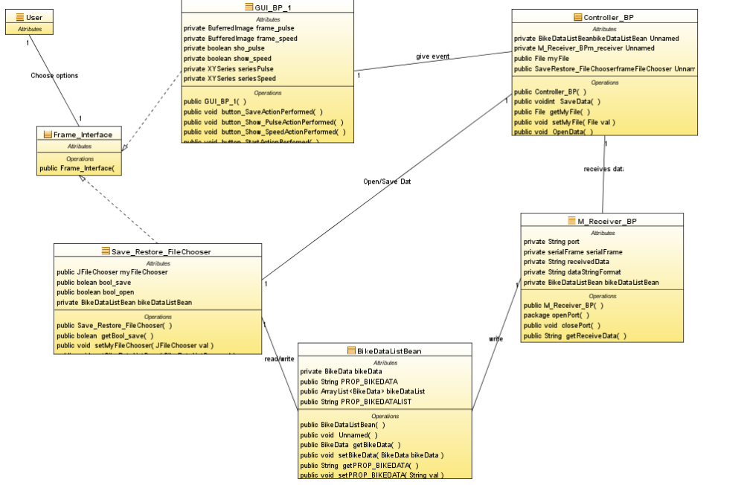

Basically this design model uses the same classes as the domain model, so we only have to say that here we see all the attributes and functions that manage the info between the classes.

However in this design model we added an abstract class that shows the graphic interface, the name of this class is Frame_Interface. Here we use this class only to show how the graphical interface works and what classes implement this graphical interface and how this classes works in our project.

As we say before we use the Model View Controller pattern, so here we show how the classes works with the graphical interface and how we use the Controller_BP (controller), this controller manage the events that came from the graphical interface, and then it makes that the model be able to control the data that will be saved, open and received.

Solution classes/Interfaces

Class name: Frame_Interface.
Responsibility:  This is an abstract class that helps to show how the graphical interface works and what classes implement this graphical interface and how this classes works in our project. | Collaboration:  GUI_BP  Save_Restore_FileChooser

Use case realization

Monitor_Speed

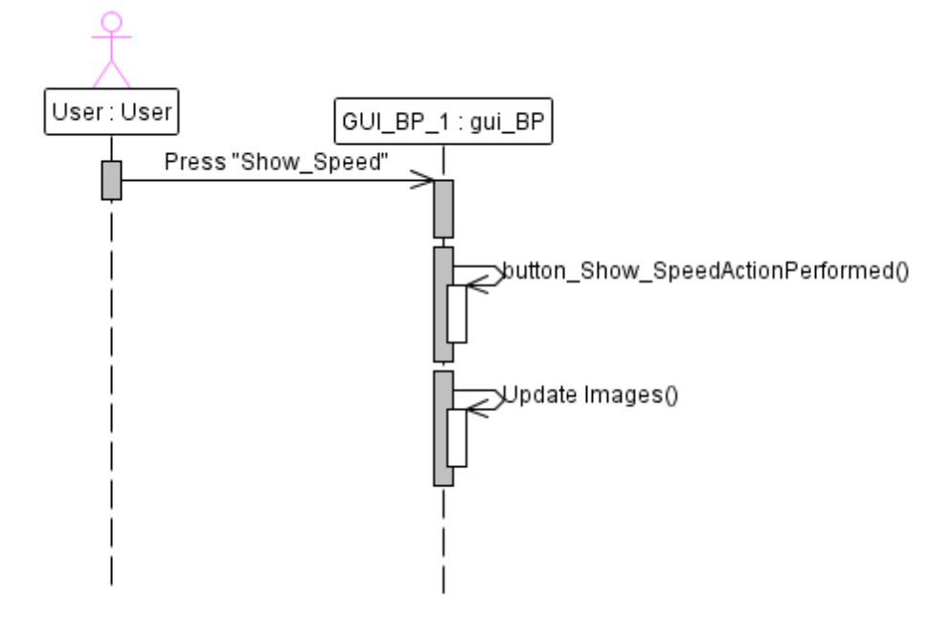
On this diagram we see the steps that the user has to follow to watch the monitor graphic that shows the evolution of the Speed.

User : is the person that chooses option and manages the BMA.

gui_BP : is the object that represents the graphical interface, (the view of the MVC), implements all the methods to show the graphics to the user (except the fileChooser).
- button_Show_SpeedActionPerformed(), this method makes that the gui_BP, shows the user the Speed graphics.
- Update Images() makes that the gui_BP repaint the graphics again.

Monitor_Pulse

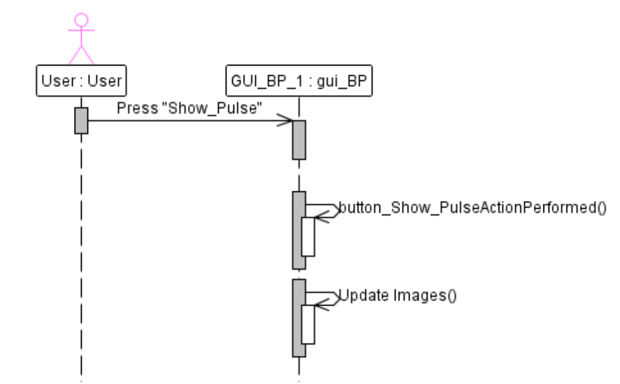
On this diagram we see the steps that the user has to follow to watch the monitor graphic that shows the evolution of the Pulse.

User : is the person that chooses option and manages the BMA.

gui_BP : is the object that represents the graphical interface, (the view of the MVC), implements all the methods to show the graphics to the user (except the fileChooser).
- button_Show_PulseActionPerformed(), this method makes that the gui_BP, shows the user the Speed graphics.
- Update Images() makes that the gui_BP repaint the graphics again.

Problem solution, Communication protocol
The BC -system Simulator uses a class called Transmitter (in the package simulator.model) and all the classes from the package bma.serial, to transmit the information in the port. The information transmitted is a String that has this format
“p”+(int)Pulse+”s”+(int)Speed+”g”+(int)Gear, for example:
p34s51g5, this means that the pulse is 34, speed is 51 and the gear is 5

We receive this information in the BMA using the same package used in the simulator (package bma.serial) an the class M_Receiver_BP (to receive) and the class Parser in the package bikeproject.model. The class Parser is used to separate the data of the string, so we put the pulse, speed and gear in the positions 1, 2 and 3 in a String[]. After with the M_Receiver_BP we obtain the pulse,speed and gear (helped bby the class Parser), an we keep this data in the class BikeDataListBean.

Testing

PC part

Acceptance Tests
The Acceptance tests are used to act like an execution of the requirements, because this involves generally a suite of test on the completed system. Each individual test operates in condition of the user's environments.
Here the tests provided where made to show if the application accomplish the requirements, like :
- Show/not Show Pulse or Speed Graphic
- Start / Stop receiving data in the BMA
- Reset the info received in the BMA
- Save / Open a file (training session) with the fileChooser.

These are the two acceptance test :
- TC1: Watch and Stop watching the Speed Graph and Pulse Graph.
- TC2: Save/Open Training Session

To see the detailed results go to the Appendix “9.4.1 Acceptance Tests”

Unit Tests

The aim of this kind of test is to watch the possible errors in the different classes of our program, this consist of sequences of method invocations of the class that we are going to test. This type of test helps to the programmers to find early errors.
This unit test will be wrote once, and will run every time that there is a change on the class tested. In this project this are the classes that were tested
- SaveRestore_FileChooser
- M_Receiver_BP
- Controller_BP

All the results of this test are in the Appendix in this part “9.4.2 Tests”.

Conclusion

Product oriented conclusion

PC part
The MVC pattern was used here, but probably not all the functions and classes are accurate to fit this pattern, specially if we take a view in the graphical interfaces. It will be a good improvement for this pogram to make that all the classes and functions work according to the MVC pattern, this will help to maintain a certain independence between the classes, and the way how we manage the information and events in the program.

The classes that are part of the MVC are listed below
Model
- BikeData
- BikeDataListBean
- M_Receiver_BP
- Parser
- SaveRestore_FileChooser
View
- GUI_BP_1
Controller
- Controller_BP

To make this project we also use packages and classes used in the projects made in the classroom. All this classes we used in the project with few or without modification

From the package bma.serial
  - FrameEvent
  - FrameEventListener
  - SerialFrame

From the package bma.model
- BikeData
- BikeDataListBean
- MonitorReciver
- Parser

To Draw the Speed/Pulse Graphic, we use a library called JFreeChart compiled and tested that gives a good interface and that has many good methods that helps in the way of using and showing the data received. This library was used because it was found many problems trying to paint a Jpanel into a Jframe created by NetBeans, this problem could because of the redefinition of the method “paintComponent”, that I was implementing in the Jpanel. To install this library see the Appendix 9.7 Install JFreeChart

There are few problems with the swing functions.

In the main window it takes a little bit of time, to watch all the features and buttons of the program, this problem must be referred to the function paint.

There is a problem with restoring of an training session, the drawing of the Speed / Pulse Graphic has problems, because it doesn't show all the data took from the file (training session).

This kind of problems can be solved if there is a deep research about the management of the function swing and specially the paint function.

Process oriented conclusion

In this project we tried to use the MVC, but as it was said before not all the classes and functions fit this pattern. On the other hand, it was so important to make a java, and specially an oriented object project with this kind of pattern, because this is so helpful to the programmers , to fix future problems, to implement new functionalities in this project or even to reuse part of the code or classes in other project that can be improved and easily understandable with the tested classes from this project.

Literature
IBM, (May 2009) http://www.ibm.com/developerworks/rational/library/782.html

Java Sun Microsystem (May 2009) http://java.sun.com/j2se/1.4.2/docs/api/allclasses-noframe.html

NCSU COE People (May 2009) http://people.engr.ncsu.edu/txie/publications/tacas05.pdf

Roseindia (May 2009 )
http://www.roseindia.net/chartgraphs/xyline-chart.shtml

Free Encyclopedia Wikipedia (May 2009) http://www.wikipedia.org/

Theserverside (May 2009) http://www.theserverside.com/tt/articles/content/LightweightModeling/appendix.html

Appendices

Glossary

PC part
PC Glossary
AVR
BC-system | BC abbreviation for Bike Computer, which refers to the hardware and software on the AVR board.
Bike Data | A sample of corresponding data from the BC-system.
BMA | Bike Monitor Application
UML | Unified Modeling Language
UP | Unified Process
Bike rider | The person currently using the exercise bike.

Time schedule

PC part

Iteration | Date Start | Date End
Iter. 1 | Start: 06/03/09 | End: 24/03/09
Iter. 2 | Start: 25/03/09 | End: 12/04/09
Iter. 3 | Start: 13/04/09 | End: 29/04/09
Iter. 4 | Start: 30/04/09 | End: 05/05/09
Iter. 5 | Start: 06/05/09 | End: 19/05/09
Iter. 6 | Start: 19/05/09 | End: 26/05/09

Action item list

PC part

Item name | Days expected to finish it | Days spent to finish it | Status | Responsible
GUI_BP | 3 | 4 | Done | Sebastian
M_Reciever_FileChooser | 2 | 3 | Done | Sebastian
Save_Restore_FileChooser | 3 | 2 | Done | Sebastian
BikeDataListBean | 1 | 1 | Done | Sebastian

Test results, PC part

Acceptance Tests

TC1: Watch and Stop watching the Speed Graph and Pulse Graph.
Tested by:
Purpose: | To Verify that:  - An arbitrary number of Pulse – and speed graphs monitored.
Test sequence: | - Start the Bike Data simulator  - Monitor Speed Graph, “Press Show_Speed”  - Press Start on the BMA  - Monitor Pulse Graph “Press Show_Pulse”  - Wait 100 seconds.  - Stop watching Pulse Graph.  - Minimize the BMA.  - Maximize the BMA  - Stop watching Speed Graph  - Monitor Pulse Graph  - Monitor Speed Graph
Description of the expected result: | - The Pulse Graph is shown  - The Speed graph is shown.  - The Pulse Graph is stopped, and don't show the incoming data.  - The BMA is Minimized  - The BMA is Maximized showing only the Speed Graph, now we don't watch the frame of the Pulse Graph  - The Speed Graph is stopped, and don't show the incoming data.
Result of the test. | Accepted
Tester’s comments: | The test was accepted normally and without any remarkable effect, there is only one thing, when we stop watching the Speed/Pulse Graph, the graphic is frezzed. But if we minimize the main window that graph disappears, but the test is accepted because this behaviour is not contrary to the functional requirements.

TC2: Save/Open Training Session
Tested by:
Purpose: | To Verify that:  - The BMA enables the user to save and open a file (training session)
Test sequence: | - Start the Bike Data simulator  - Press Start on the BMA  - Monitor Speed Graph, “Press Show_Speed”  - Monitor Pulse Graph ,“Press Show_Pulse”  - Wait 100 seconds.  - Stop the BMA  - Press Save  - Save the training session with the name test1.txt  - Press Reset  - Press Open, and select the training session caleed test1.txt
Description of the expected result: | - The Pulse Graph is shown  - The Speed graph is shown.  - After pressing Stop, the Pulse and Speed Graph are stopped.  - After pressing Save, appears a fileChooser, and we can save the data with the name test1.txt  - With the Reset, the Pulse and Speed Graph are reinitialized  - After pressing open, appears a fileChooser, and we can choose the data with the name test1.txt  - The Pulse and Speed Graph , show the graphical information of the test1.txt.
Result of the test. | Accepted but whit comments
Tester’s comments: | The result are like we expected, all the things were good. But when we open the file1.txt, the Pulse and Speed Graph are painted but not all the data from the file is painted, I realized that all the data is well kept on the BikeDataListBean, and this information is passed correctly to the GUI_BP_1, so this is probably a problem with the functions of the swing.

Unit Tests

UNIT TESTS
Class | Type of test | Expected Results | Showed Results | Pass
SaveRestore_FileChooser | Save a file called test1.txt, with information from BikeDataListBean | The creation of a file called test1.txt, with information from BikeDataListBean | The creation of a fil called test1.txt, with information from BikeDataListBean | Yes
SaveRestore_FileChooser | Open a file called test1.txt, with information | The opening of a file called test1.txt, wich information will be saved in an object of BikeDataListBean | The opening was succes and the data was keep in an object of BikeDataListBean | Yes
M_Receiver_BP | The correct reception of data | The data received will be display on the screen | Every time that a new data is received, this is displayed on the screen | Yes
Controller_BP | Test that the controller_BP calls the fileChooser (with the open optin) from the SaveRestore_FileChooser | It must appear a fileChooser whit the open button option | Appears a fileChooser whit the open button option | Yes
Controller_BP | Test that the controller_BP calls the fileChooser (with the save optin) from the SaveRestore_FileChooser | It must appear a fileChooser whit the save button option | Appears a fileChooser whit the save button option | Yes

Source code Java
(On CD only)

Use case specifications

Use Case: Monitor Pulse
ID:1
Brief description:
The user choose to watch the monitor graphic that shows the evolution of the Pulse
Primary actors:
User
Secondary actors:
Bike computer
Preconditions:
None. This only enables the user to watch the Pulse graphic with or without the data received from the simulator.
Main flow:
- The systems shows us the GUI (the main window), where the user can choose different options
- The user choose this option, pressing the button called “Show_Pulse”
- The system shows the Pulse graphic.
- The user is able to watch the Pulse graphic with or without the data received from the simulator.

Post conditions:
The user can watch the Pulse graphic

Alternative flows:
- None

Use Case: Monitor Speed
ID:1
Brief description:
The user choose to watch the monitor graphic that shows the evolution of the Speed
Primary actors:
User
Secondary actors:
Bike computer
Preconditions:
None. This only enables the user to watch the Speed graphic with or without the data received from the simulator.
Main flow:
- The systems shows us the GUI (the main window), where the user can choose different options
- The user choose this option, pressing the button called “Show_Pulse”
- The system shows the Speed graphic.
- The user is able to watch the Speed graphic with or without the data received from the simulator.

Post conditions:
The user can watch the Speed graphic

Alternative flows:
- None

Use Case: Restore DataBike
ID:1
Brief description:
The user can choose a file to restore a previous training session
Primary actors:
user
Secondary actors:
Bike computer
Preconditions:
- The user must press the buttons “Show_Pulse” and “Show_Speed”, to watch the graphic info from the Pulse and the Speed.

- If the user only wants the data from the restored session, before opening file the user must stop the reception of data, pressing the button “Stop” and then to reset the data and graphics the user must press the button “Reset”. Otherwise if there is a session started the restored training session will be added to this session.

Main flow:
- The systems shows us the GUI (the main window), where the user can choose different options
- The user choose this option, pressing the button called “Open Data”.
- A window appears, here the user has to choose the location of the file to be restored.
- The system shows the Pulse and Speed graphic, from the restored training session
- The user is able to watch the Pulse and Speed graphic from the restored training session.

Post conditions:
The user can watch the Pulse and Speed graphic from the restored training session.
Alternative flows:
- None

Use Case: Save DataBike
ID:1
Brief description:
The user can choose a file to save previous training session
Primary actors:
user
Secondary actors:
Bike computer
Preconditions:
The user must press the buttons “Start” to receive the info from the Simulator. Otherwise there wold not be data to save.
Main flow:
- The systems shows us the GUI (the main window), where the user can choose different options
- The user choose this option, pressing the button called “Save”
- A window appears, here the user has to choose the location and the name of the file to be saved.
- The user now keep the data from the present training session.

Post conditions:
The user now keep the data from the present training session.
Alternative flows:
- None

Install JFreeChart
To install this library we have to follow this steps :
1) Download and unzip the JFreeChart y JCommon files
("jfreechart-1.0.13" and "jcommon-1.0.16")

2) Copy the "jcommon-1.0.16.jar" and the "jfreechart-1.0.13.jar" files
to the <jdk>\jre\lib directory.

3)In order to use the JFreeChart y JCommon files from within JBuilder, it must be
set up to use the "jcommon-1.0.16.jar" and the "jfreechart-1.0.13.jar" files.

4) Choose File, Project Properties.

5) In categories, select Libraries

6) Select the compile tab and Add JAR/Folder

7) Select the jcommon-1.0.16.jar in the dialog box.

8) Select the jfreechart-1.0.13.jar in the dialog box.

9) Select Open and OK

